The Yorkshire and The Humber Maternal Medicine Network

Neurology Principles

**Purpose and Scope**

The Yorkshire and Humber (Y&H) region have come together to develop the Y&H Maternal Medicine Network (MMN). The aim of the MMN is to align care across the region and to reduce inequalities in care to women/ birthing people with complex medical conditions.

The purpose of this document is to outline the key principles that should be adopted when caring for women/ birthing people with neurological problems including epilepsy and multiple sclerosis. The document also identifies the red flags for women/ birthing people presenting with headaches in pregnancy.

This document should be used in conjunction with the ‘Conditions for Consideration of Referral to the Maternal Medicine Centre’ document, which can be found at [www.maternalmedicine.org.uk](http://www.maternalmedicine.org.uk)

This document has been approved by governance at both LTHT and STH. This document can either be used as a standalone document following ratification by adopting Trusts or can be used as a reference to incorporate into Trust guidance.

**Introduction**

Epilepsy is the most common serious neurological condition encountered in pregnancy, with a prevalence of 0.5–1%. An estimated 2500 infants are born to women/ birthing people with epilepsy every year in the UK. Risks of epilepsy in pregnancy include increased seizure activity, fetal congenital malformations associated with anti-seizure medication (ASMs) and a small but significant increase in obstetric risks including fetal growth restriction (RCOG 2016).

Most pregnant women/ birthing people with epilepsy, who are receiving optimal treatment for their epilepsy, and who are well informed, supported and fully counselled have uncomplicated pregnancies, normal births and healthy children. However, the risk of death is increased ten-foldin pregnant women/ birthing people with epilepsy compared to those without. More women/ birthing people die from epilepsy during pregnancy than die as a result of pregnancy hypertensive disorders (Knight et al 2017). Twice as many women/ birthing people died during or up to a year after the end of pregnancy in 2016-2018 from causes related to epilepsy, compared to 2012-2015. In these cases, SUDEP was the main cause of death (MBRRACE 2020).

Multiple sclerosis is a chronic neurological condition that manifests with clinical and subclinical attacks of central nervous system demyelination. Whilst pregnancy has no adverse effect on long term disease progression, it is associated with a higher relapse rate in the immediate post-natal period (Kanagaraj, P. Evangelou, N. Kapoor, D. 2019).

Findings from national reports, such as MBRRACE, have shown that those who are from a Black, Asian or Mixed Ethnic Background or those who have a severe mental illness or live in the most deprived neighbourhoods, are at higher risk of poorer physical health and care outcomes in addition to their medical condition/s. Therefore, it is important to consider the person’s individual needs, circumstances and wider determinants of health and offer reasonable adjustments to address these to ensure improved equity of access, support and care for individuals. The perinatal period adds a further complexity, therefore please consider the mental wellbeing, learning and informational needs of the patient and refer and signpost to local services as appropriate. The YH Mental Health Clinical Network website provides useful information and signposting: [https://www.yhscn.nhs.uk/mental-health-clinical-network](https://gbr01.safelinks.protection.outlook.com/?url=https%3A%2F%2Fwww.yhscn.nhs.uk%2Fmental-health-clinical-network&data=05%7C01%7Cdebbie.scott14%40nhs.net%7C0f6583d89d594e95d19508db5d0819a7%7C37c354b285b047f5b22207b48d774ee3%7C0%7C0%7C638206061584938251%7CUnknown%7CTWFpbGZsb3d8eyJWIjoiMC4wLjAwMDAiLCJQIjoiV2luMzIiLCJBTiI6Ik1haWwiLCJXVCI6Mn0%3D%7C3000%7C%7C%7C&sdata=rpzYkJT8UFaof7gngsIAQYYGW396a3rIObo1wyAnVL4%3D&reserved=0)

**Epilepsy Principles**

ASM=Antiseizure medication

|  |
| --- |
| **Epilepsy in Pregnancy General Principles of Care** |
| Optimise seizure control with the lowest effective dose of the most appropriate ASM |
| Provide written information about epilepsy, ASMs and pregnancy implications. |
| In women taking levetiracetam, lamotrigine, carbamazepine, phenytoin and phenobarbitol serum drug levels may be helpful; testing of serum ASM levels should be performed in conjunction with the woman’s epilepsy team |
| Early discussion with an epilepsy specialist is required if there is a deterioration in seizure control |
| Women should be made aware that pregnancy is a risk factor for SUDEP (MBRRACE 2020). |
| Risk factors for SUDEP should be discussed with the woman and her partner and how to minimise the risk. (Appendix 1). |
| Regard Nocturnal Seizures as a red flag that require urgent referral to a combined Obstetric / Epilepsy clinic (MBRRACE 2020). |
| Safety advice and strategies should be part of the antenatal and postnatal discussions |

|  |  |  |  |  |  |
| --- | --- | --- | --- | --- | --- |
| **Epilepsy- Pre pregnancy care** | | | | | |
| Offer the opportunity to plan pregnancy with an epilepsy specialist and an obstetrician | | | | | |
| Recommend folic acid 5mg od for 3 months prior to conception | | | | | |
| Review current ASMs and counsel regarding congenital malformation risks. Women taking sodium valproate or topiramate should be switched to another ASM where possible. | | | | | |
| **Epilepsy- Antenatal care** | | | | | |
| Continue folic acid 5mg od until 12 weeks gestation | | | | | |
| Women should receive care from both an obstetrician and an epilepsy specialist in their local unit. Consider referral to the MMN if this is not available locally and/ or if the epilepsy is poorly controlled or taking 2 or more ASM’s. | | | | | |
| Women who find themselves pregnant unexpectedly should be reviewed at the earliest opportunity for ASM review and counselling | | | | | |
| Encourage registration with the UK Epilepsy and Pregnancy Register | | | | | |
| Assess regularly for risk factors for seizures (such as sleep deprivation and stress), adherence to ASMs and seizure type and frequency | | | | | |
| Offer serial growth scans to women on ASMs | | | | | |
| **Epilepsy- Intrapartum care** | | | | | |
| Advise hospital birth | | | | | |
| ASM intake should be continued throughout labour and delivery | | | | | |
| Seizures lasting longer than 3 minutes should be terminated according to local protocol as soon as possible to avoid maternal and fetal hypoxia and fetal acidosis. | | | | | |
| All units should have a guideline for management of status epilepticus and the relevant drugs should be readily available on the Delivery Suite | | | | | |
| **Epilepsy-Postnatal care** | | | | | |
| All women with epilepsy should have a postnatal ASM plan documented in advance | | | | | |
| Encourage breastfeeding | | | | | |
| Arrange appropriate follow up with the local epilepsy specialist or GP | | | | | |
| Offer contraceptive advice (considering ASM medication) | | | | | |
| Discuss postnatal strategies to ensure safety of infant, including nursing the baby on the floor, using very shallow baby baths, laying the baby down if there is a warning aura, not bathing the baby unaccompanied, wearing identification tags, and avoiding sleep deprivation and alcohol if prone to myoclonic jerks. | | | | | |
|  | | | | | |
| **Risk of Major Congenital Malformations for Different ASM- Registry Data** | | | | |
| **Anti-Seizure Medication (ASM)** | **UK & Ireland Registry** | **EURAP** | **Australian Registry** | **North American Registry (up to May 2022)** |
|  |  |  |  |  |
| Levetiracetam | 0.70% | 2.80% | 2.40% | 2% (n=1228) |
| Lamotrigine | 2.3% (2014) | <300mg 2.0% ≥300mg 4.5% | 4.60% | 2.1% (n=2397) |
| Carbamazepine | 2.6% (2014) | <400mg 3.4% ≥400mg-<1000mg 5.3% ≥1000mg 8.7% | 4.60% | 2.8% (n=1127) |
| Valproate | 6.7% (2014) | <700mg 5.6% ≥700mg-<1500mg 10.4% ≥1500mg 24.2% | 13.80% | 9.2% (n=336) |
| Topiramate | 4.30% | 3.90% | 2.40% | 5.1% (n=509) |
| Oxcarbazepine | N/A | 3.00% | N/A | 1.6% (n-317) |
| Phenobarbital | N/A | 6.50% | N/A | 5.50% |
| Phenytoin | 3.7% (2006) | N/A | N/A | 2.8% (n=423) |
| Zonisamide | N/A | N/A | N/A | 1.4% (n=217) |
| Lacosamide | N/A | N/A | N/A | 0% (n=80) |
| Clonazepam | N/A | N/A | N/A | 1.8% (n=114) |
| Gabapentin | N/A | N/A | N/A | 1.5% (n=261) |
| Pregabalin | N/A | N/A | N/A | 1.8% (n=56) |

**Multiple Sclerosis (MS) Principles**

|  |
| --- |
| **M.S. Pre- pregnancy care** |
| Recommend folic acid 400microg od for 3 months prior to conception |
| Review current MS medication with MS specialist and counsel regarding congenital malformation risks. |
| Recommend Vitamin D supplements |
| Recommend that disease-modifying treatment should not be deferred if planning pregnancy (risk of being off-treatment for extended period of time) |

|  |
| --- |
| **M.S- Antenatal care** |
| MS should not influence obstetric management |
| Inform the MS team caring for the woman as soon as pregnant |
| MS does not increase the risk of pre-eclampsia (so should not influence decisions about aspirin prophylaxis) |
| Consider referral for anaesthetic assessment |
| Additional growth scans are not required in MS |
| UTI is more common in pregnancy with MS and should be treated promptly |
| Refer for MDT assessment (incl specialist physio) if the woman is experiencing mobility problems that are likely to impact ability to care for herself or baby |
| Relapses are less common in pregnancy but if they occur they should be treated promptly with methylprednisolone in conjunction with the MS Team |
| Inform all women with MS about the UK MS register and ask them to consider joining., information available at - https://www.ukmsrgister.org/pregnancy |

|  |
| --- |
| **M.S- Intrapartum care** |
| MS should not influence mode of delivery or analgesia unless there is significant disability |

|  |
| --- |
| **M.S- Postnatal care** |
| Encourage breastfeeding (after reviewing safety of medications) |
| Women with MS may require additional support from family/friends and MDT in the postpartum period: this should be planned in advance of the birth. |

|  |  |  |  |  |
| --- | --- | --- | --- | --- |
| **Summary of MS Medication Use in Pregnancy** | | | | |
| **MS Medication** | **For use in pregnancy?** | **Shown to increase risk of miscarriage or birth defects** | **Give last dose (*risk of rebound relapse after stopping)** | **Is breastfeeding safe?** |
| **IFN-B and Glatiramer Acetate** (Avonex, Betaferon, Extavia, plegridy, Rebif, Copaxone) | Yes | No | Can continue throughout pregnancy | Yes |
| **Natalizumab** Tysabri | Yes | No | 34 weeks into pregnancy * | Yes |
| **Ocrelizumab** Ocrevus | Not routinely | No | 3 months pre-conception | Yes |
| **Ofatumumab**  Kesimpta | Not routinely | No | Can be used until conception, may prefer to wait 3 months from last dose | Yes |
| **Dimethyl fumerate**  Tecfidera | No | No | No set recommended washout period | Potentially yes, discuss with specialist |
| **Alemtuzumab**  Lemtrada | No | No | 4 months pre-conception | No - 4 months after last dose |
| **Cladribine** Mavenclad | No | Yes | 6 months pre-conception | No - 1 week after last dose |
| **Fingolimod**  Gilenya | No | Yes | 2 months pre-conception * | No - 2 months after last dose |
| **Ponesimod** Ponvory | No | Yes | 1 week pre-conception | No - 1 week after last dose |
| **Siponimod**  Mayzent | No | Yes | 10 days pre-conception | No - 10 days after last dose |
| **Teriflunomide**  Aubagio | No | Yes | 2 years pre-conception or 6 weeks if accelerated elimination | No |

|  |
| --- |
| **Red flags in history and examination in woman presenting with headache in pregnancy** (Royal College of Physicians 2019). |
| Sudden-onset headache / thunderclap or worst headache ever |
| Headache that takes longer than usual to resolve or persists for more than 48 hours |
| Has associated symptoms – fever, seizures, focal neurology, photophobia, diplopia |
| Excessive use of opioids |

**Appendix 1** (MBRRACE 2020)

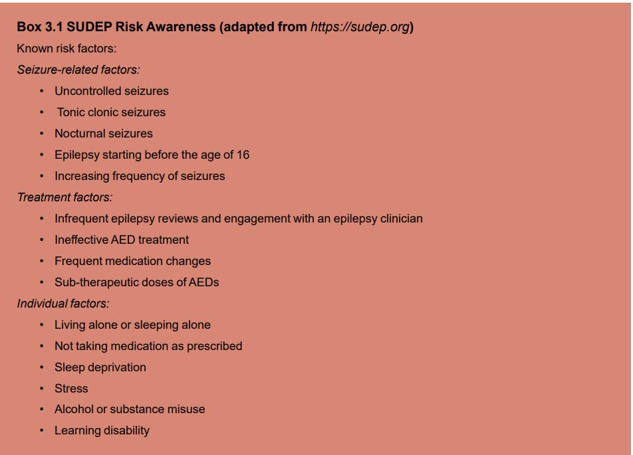

References

Kanagaraj, P., Evangelou, N. and Kapoor, D. (2019) Multiple Sclerosis and Pregnancy. The Obstetrician & Gynaecologist, 211, 177-184.

Knight, M., et al., (2017). Saving Lives, Improving Mothers’ Care - Lessons learned to inform maternity care from the UK and Ireland Confidential Enquiries into Maternal Deaths and Morbidity 2013-15. Oxford, National Perinatal Epidemiology Unit, University of Oxford

MBRRACE-UK - Saving Lives, Improving Mothers’ Care (2020)

Royal College of Obstetricians and Gynaecologists (2016b). Green-top Guideline 68: Epilepsy in Pregnancy. London, RCOG.

Royal College of Physicians (2019). Acute Care Toolkit 15- Managing acute medical problems in pregnancy, Nov 2019.

UK MS Pregnancy Register Steering Group and Judge-Clayden, F. Multiple Sclerosis (MS) and Pregnancy, V.1, March, 2022.

|  |  |  |  |  |  |  |
| --- | --- | --- | --- | --- | --- | --- |
| **Document Control** | | | | | | |
| **Name:** | | |  | | **First published:** | September 2023 |
| **Version:** | | | V1 | | **Current Version Published:** | September 2023 |
| **Ratification Committee:** | | | Leeds Teaching Hospitals, Sheffield Teaching Hospitals, Women’s Clinical Support Group Quality Assurance Group | | **Review Date:** | September 2026 |
| **Document Managed by**  **Name:** | | | Debbie Scott | | **Document Managed by Title:** | Consultant Midwife MMN |
| **Consultation Process** | | | | | | |
| Y&H Maternal Medicine Network, ratified at Leeds Teaching Hospitals and Sheffield Teaching Hospitals, Women’s Clinical Support Group Quality Assurance Group …. | | | | | | |
|  | **Version Control** | | | | | |  |
|  | **Date** | **Version** | | **Contributor** | **Revision description** | |  |
|  | March 2023 | V1 | | As above | New policy | |  |